Interpolation
Explained: | interpolation  linear interpolation  ordinary interpolation  quadratic interpolation

Interpolation is any procedure for fitting a function to a set of points in such a manner that the function intercepts each of the points. Consider m points where , , and the are distinct. We wish to construct a function f: such that = f() for all k. There are various solutions to this problem. We consider an approach called ordinary interpolation. This is applicable to a wide range of interpolation functions.
Example: Linear Interpolation
Linear interpolation uses a linear polynomial as the interpolation function. Between two points, (x^{[1]}, y^{[1]}) and (x^{[2]}, y^{[2]}) with x^{[1]} < x^{[2]}, we interpolate a linear polynomial of the form
[1]
Consider points (2,1) and (5,3). These and an interpolated linear polynomial are graphed below.
Example: Linear Interpolation
Exhibit 1
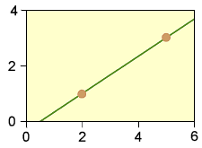
A linear polynomial interpolated between the two points (2,1) and (5,3).
Ads by Contingency Analysis
To solve for the interpolated polynomial, we must determine constants and . If the linear polynomial is to intercept (2,1) and (5,3), it must satisfy
f(2) = 2 + = 1 | [2]
f(5) = 5 + = 3 | [3]
This is a system of two linear equations in two unknowns. We express it in matrix form:
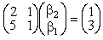 | [4]
Solving, we obtain = –1/3 and = 2/3, so our interpolated polynomial is
f(x) = 2x/3 – 1/3 | [5]
Example: Quadratic Interpolation
Quadratic interpolation uses a quadratic polynomial as its interpolation function. Suppose we want to interpolate a quadratic polynomial between the five points of Exhibit 2
Example:
Interpolation Points
Exhibit 2
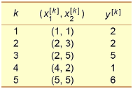
Five points through which to interpolate a quadratic polynomial.
The general form for a quadratic polynomial from ² to is
[6]
Solving for the six constants based upon the five points of Exhibit 2 would entail a system of five equations in six unknowns. Such a system is likely to have infinitely many solutions. To obtain a unique solution, we may consider a less general form of quadratic polynomial than [6]. We might require or set = 0, etc. For this example, let’s interpolate a quadratic polynomial with zero cross term, = 0. Our polynomial then has form
[7]
We require that this polynomial intercept each of our five points. This renders a system of five equations in five unknowns, which we express in matrix notation as
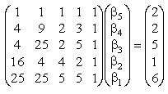 | [8]
Solving, we obtain
[9]
This and the five points are graphed in Exhibit 3.
Example: Quadratic Interpolation
Exhibit 3
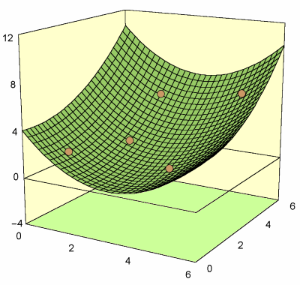
A quadratic polynomial interpolated between five points.
Methodology
We now formalize the interpolation procedure illustrated in our two examples. Those examples used polynomials as interpolation functions f. The following discussion extends the procedure to a broader range of interpolating functions.
Consider m points where , , and the are distinct. We wish to construct a function f: of the form
[10]
in such a manner that f intercepts each of the points. Functions : can take any form. In our above quadratic example, they were:
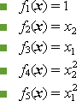
but exponentials, roots, logarithms and other functions are permissible. Let’s express our problem with matrices. Define
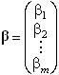 | [11]
This is unknown. It is what we want to solve for. Define f as the mm matrix comprising values of each function evaluated at each point :
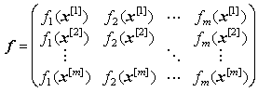 |  |  | [12]
 | Ads by Contingency Analysis
Define the vector
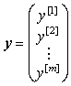 | [13]
Both the matrix f and vector y are constants. They are known. Our requirement that f intercept each point yields the equation
[14]
If the matrix f is invertible, this has the unique solution
[15]

Exercises
Consider three points (x^{[k]}, y^{[k]}) = (1,2), (4,2), (5,3). Interpolate a quadratic polynomial of the form . [solution]
Interpolate a function of the form such that f (1, 0) = 1 and f (1, 1) = 1. [solution]

Disclaimer
website: http://www.contingencyanalysis.com
glossary direct link: http://www.riskglossary.com
copyright © Contingency Analysis, 2006

